S Keerthana QUIZ
Aim:
To develop a Java program using Swing components that conducts a multiple-choice quiz with a countdown timer for each question.

Steps :
1. Start the program and create a main JFrame for the quiz interface.
2. Add components:
JLabel for displaying the question.
JRadioButtons for displaying the answer options.
ButtonGroup to group the options so only one can be selected.
JButton ("Next") to move to the next question.
JLabel for displaying the timer.
3. Initialize an array of questions and options.
4. Display the first question and start the countdown timer (30 seconds).
5. If the user clicks "Next", stop the timer and load the next question.
6. If the timer reaches 0, automatically load the next question.
7. After all questions are completed, display "QUIZ FINISHED!!!" and hide the options.

Procedure:
1. Import required Java packages:
javax.swing.* for GUI components.
java.awt.* for layout and UI.
java.awt.event.* for event handling.
2. Define the class oppsass with static variables:
timeleft, curqn, arrays for questions and options.
3. In main(), create the JFrame, labels, radio buttons, and button, and add them to the frame.
4. Implement the Nextqn() method to:
Load the next question and options.
Reset the timer to 30 seconds.
5. Implement the startTimer() method using a thread to:
Decrement the timer every second.
Update the timer label dynamically.
Call Nextqn() automatically when time is up.
6. Implement stopTimer() to interrupt the running timer thread whenever needed.
7. Compile and run the program to view the quiz.

PROGRAM:
import javax.swing.*;
import java.awt.*;
import java.awt.event.*;
public class oppsass{
static int timeleft=30;
static int curqn=0;
static String[] qn={"1.What is java?","2.What is c?","3.What is python?","4.What is java script?","5.What is c++?"};
static String opn[][]={{"a)Language","b)Pen","c)Pencil","d)Chair"},{"a)Apple","b)Ball","c)Language","d)Dog"},
{"a)Keerthana","b)Language","c)Sahhana","d)Rubiga"},{"a)Write","b)Read","c)Append","d)Language"},
{"a)Language","b)abc","c)def","d)ghi"}};
static Thread timerThread;
public static void main (String args[]){
JFrame f=new JFrame("Quiz");
JLabel l=new JLabel();
JLabel tl=new JLabel("Timeleft "+timeleft+"s");
JRadioButton r1=new JRadioButton("a)");
JRadioButton r2=new JRadioButton("b)");
JRadioButton r3=new JRadioButton("c)");
JRadioButton r4=new JRadioButton("d)");
ButtonGroup b=new ButtonGroup();
JButton next=new JButton("Next->");
next.addActionListener(new ActionListener(){
public void actionPerformed(ActionEvent e){
stopTimer();
Nextqn(l,r1,r2,r3,r4,b,tl);
}});
r1.setBounds(40,65,100,30);
r2.setBounds(40,100,100,30);
r3.setBounds(40,135,100,30);
r4.setBounds(40,170,100,30);
l.setBounds(30,30,100,30);
tl.setBounds(300,30,150,30);
next.setBounds(200,220,100,30);
f.add(l); f.add(tl);
b.add(r1); b.add(r2); b.add(r3); b.add(r4);
f.add(r1); f.add(r2); f.add(r3); f.add(r4);
f.add(next);
f.setSize(500,500);
f.setLayout(null);
f.setVisible(true);
f.setDefaultCloseOperation(JFrame.EXIT_ON_CLOSE);
Nextqn(l,r1,r2,r3,r4,b,tl);
}
static void Nextqn(JLabel qlabel,JRadioButton r1,JRadioButton r2,JRadioButton r3,JRadioButton r4,ButtonGroup b,JLabel tl){
if(curqn<5){
qlabel.setText(qn[curqn]);
r1.setText(opn[curqn][0]);r2.setText(opn[curqn][1]);
r3.setText(opn[curqn][2]);r4.setText(opn[curqn][3]);
b.clearSelection();
timeleft=30;
tl.setText("Time left "+timeleft+"s");
curqn++;
startTimer(tl,qlabel,r1,r2,r3,r4);
}
else{
qlabel.setText("QUIZ FINISHED!!!");
r1.setVisible(false);r2.setVisible(false);
r3.setVisible(false);r4.setVisible(false);
tl.setText("");
}}
static void startTimer(final JLabel tl,final JLabel qlabel,final JRadioButton r1,final JRadioButton r2,final JRadioButton r3,final JRadioButton r4){
stopTimer();
timerThread=new Thread(new Runnable(){
public void run(){
while(timeleft>0){
try{
Thread.sleep(1000);}
catch(InterruptedException e){
return; }
timeleft--;
SwingUtilities.invokeLater(new Runnable(){
public void run(){
tl.setText("Time left "+timeleft+"s");
}});}
SwingUtilities.invokeLater(new Runnable(){
public void run(){
tl.setText("Time's up!!!");
Nextqn(qlabel,r1,r2,r3,r4,new ButtonGroup(),tl);
}
});
}
});
timerThread.start();
}
static void stopTimer(){
if(timerThread!=null&&timerThread.isAlive()){
timerThread.interrupt();
}}}

OUTPUT:
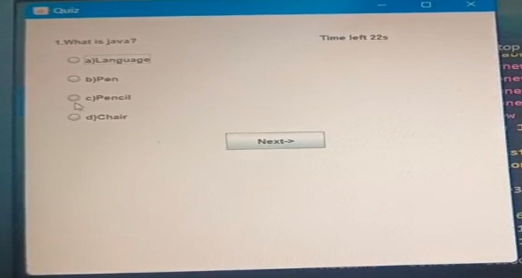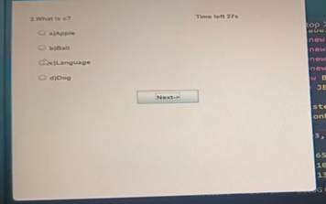

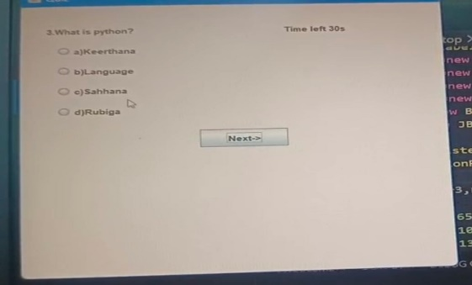
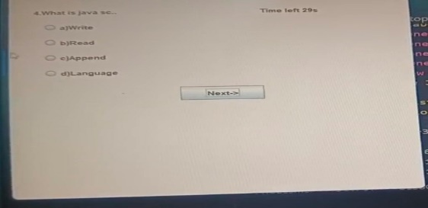
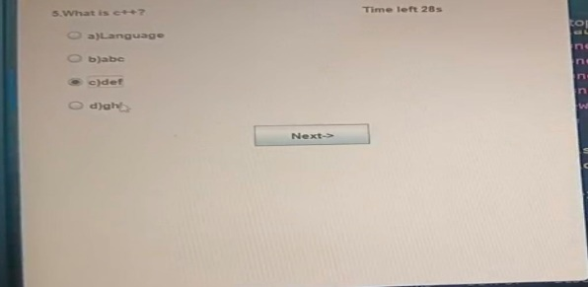
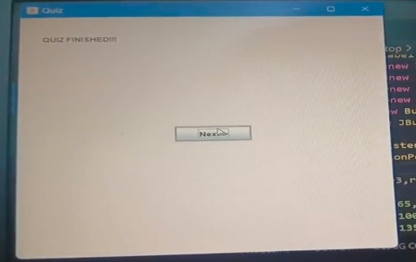

RESULT:
The Java Swing application successfully displays a quiz with multiple-choice questions.
Each question has a 30-second countdown timer.
If the timer runs out or the "Next" button is clicked, the next question is displayed.
After the last question, the program shows "QUIZ FINISHED!!!" and hides the options.

